**LAB 4**

**1. Please use steghide and conceal your data. Cover File should be your favourite actor's image and secret file should contain you name and roll number as your text.**

**Secret file and Cover file:**

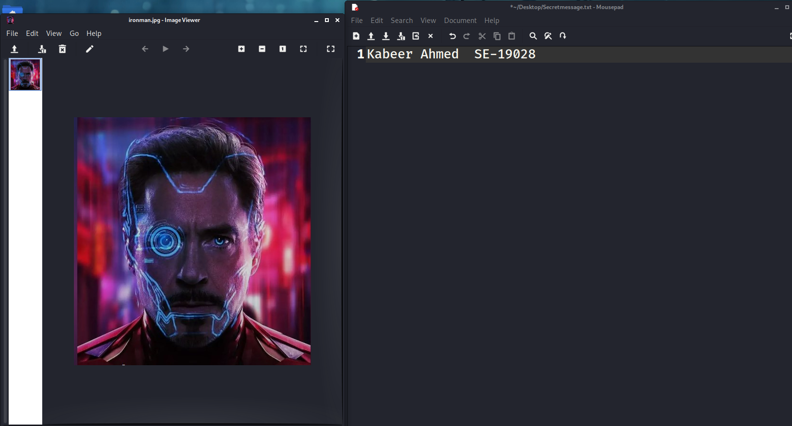

**Command:**

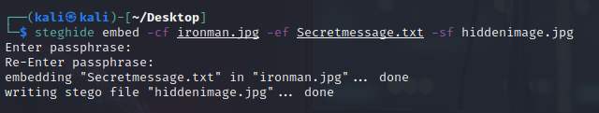

**Output file:**

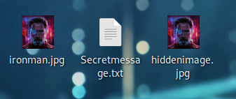

**Exercise**

**1. Create a secret message containing your name and roll number along with “The World is Real. Be good to yourself.” Embed the file ‘secretmessage.txt‘ inside the cover file ‘coverfile.jpg‘ and name the output stegofile ‘hiddenmessage.jpg‘. What is the full command you would use to do this?**

**Secret file and cover file:**

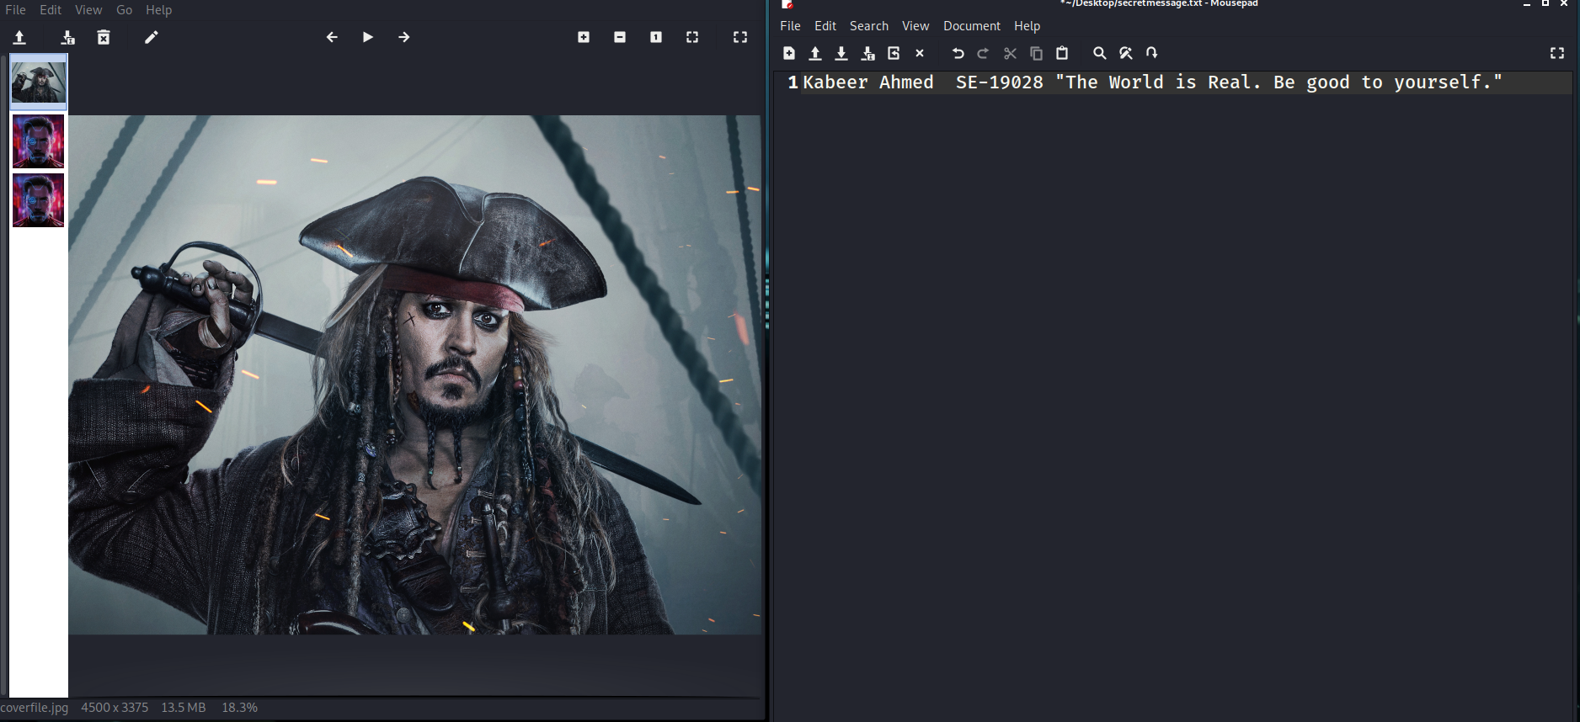

**Command:**

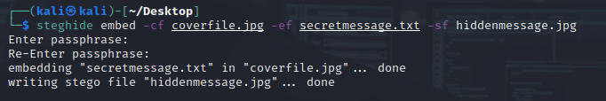

**Output file:**

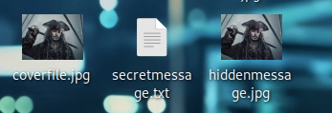

**2. Extract the secret message send by your fellow student. What is the message and how to extract it?**

**Hiddenmessageimage:**

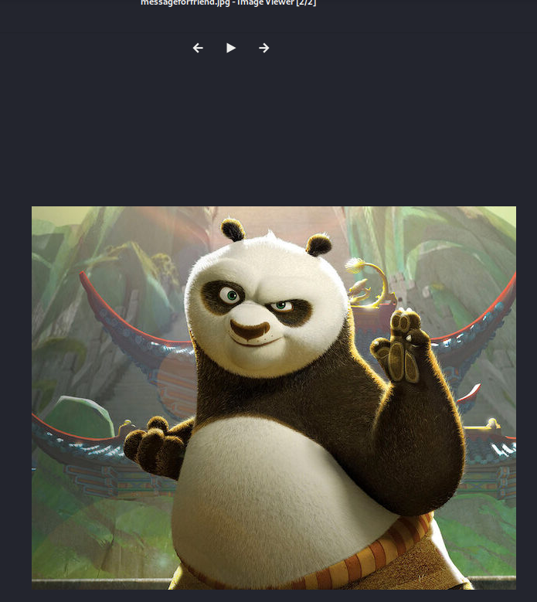

**Passphare: nizam123**

**Command:**

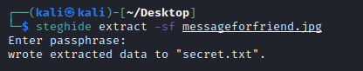

**Secretmessage:**

